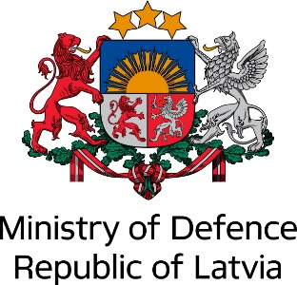 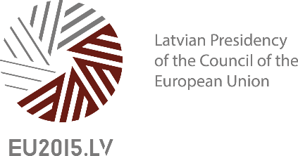 

**2nd National Cyber Security Strategies Workshop**

Co-organised by

The Ministry of Defence of the Republic of Latvia and

The European Union Agency for Network and Information Security (ENISA)

within the Latvian Presidency of the Council of the European Union

13 May 2015, Riga, Latvia

Practical Information

**Venue and Timeframe**

The conference will be held in Radisson Blu Rīdzene Hotel <<http://www.radissonblu.com/ridzenehotel-riga/contact>>, Reimersa 1, Rīga.

The event will start with registration and a welcome coffee. It will continue in three sessions. Those will take place in a conference room on the ground floor. You fill find signs with directions to the respective rooms in the entrance area of the Radisson Blu Rīdzene Hotel.

Wireless internet access (WiFi) will be available throughout the conference venue. Username and password will be shared with the participants upon registration.

The conference will begin at 08:30 and end at approx. 17:00. Please be aware that local time in Riga is UTC+3.

Please note that the event will take place back to back with the 10th ENISA CERTs workshop on May 11-12 in Riga. Participants that are invited to attend both events should account for that when booking their hotels and making their travel arrangements.

**Accommodation**

Accommodation is in the responsibility of the participants.

There are several hotels that are located in direct vicinity (approx. 5 -7 min. walk) of the conference venue:

1. HOTEL OPERA (<http://www.operahotel.lv/>)

* 5 mins walk

 2. TALLINK Hotel Riga (<http://www.tallinkhotels.com/tallink-hotel-riga>)

* 5 mins walk

3. SemaraH Hotel Metropole (<https://www.semarahhotels.com/en/metropole-hotel/contacts/>)

* 5 mins walk

4. Europa Royale (<http://www.groupeuropa.com/europa_royale/riga_hotel/>)

* 7 mins walk

The Old Town of Riga offers many different hotels that are available for booking through the usual online booking services. The Old Town is located at the east side bank of the river Daugava. The hotel is very close to the Old city and many other hotels. Participants will have an opportunity to enjoy Latvia’s green city and take a short walk through some parks and gardens. We highly recommend participants to book the hotels as soon as possible because there is high demand due to the Latvian Presidency of the Council of the European Union, meanwhile prices remain acceptably low if you book well in advance.

**Transportation**

Transportation is in the responsibility of the participants.

***Travel to Riga by Air***

Riga International Airport (RIX) is located just 10 km from the city centre and is easily accessible by public transport or taxi.

Riga International Airport

RIGA Airport 10/1

Mārupes novads

Riga, LV-1053, Latvia

[www.riga-airport.com/en](http://www.riga-airport.com/en)

Airport inquiries service: +371 29311817

***Getting from the Airport to the City***

Getting to the city centre or Old Town from the airport takes ~25-30 min. by public transport or taxi.

Taxi services are available at Riga airport 24 hours a day and are located outside the arrivals area. The average fare from the airport to the city centre or Old Town is € 10-20. The fare increases with both distance and time. Green *AirBaltic* and red *Riga Cab* taxi services are recommended.

An Airport Express hotel shuttle operated by *AirBaltic* (green minibuses) runs every 30 min. and picks up passengers near the exit of the Schengen arrivals hall (Arrival E). It costs € 5.00 (cash only) for a one-way journey and takes passengers only to the following hotels: Hotel ABC, Islande Hotel, Maritim Park Hotel, Hotel Riga (Old Town), Opera Hotel, Tallink Hotel, Radisson Blu Hotel, Albert Hotel, PK Riga Hotel, Monica Centrum Hotel.

Public transport bus no 22 connects the airport with the city centre. The bus stop is located behind car park P1 opposite Arrival E. The service operates up to every 15 min. from Mondays to Fridays and up to every 20 min. on Saturdays and Sundays. It can take up to 30 min. to reach the centre. For fares, see the *Transportation around Riga* section.

More information and the schedule for bus no 22 can be found at <http://saraksti.rigassatiksme.lv/index.html#bus/22/b-a/en>.

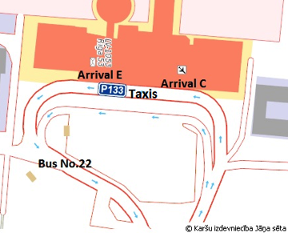

**Bus and taxi stops at the airport**

***Transportation in Riga***

Riga has a frequent and extensive public transport network of buses, trams and trolleybuses which run around the Old Town and across the bridge, with a stop close to the conference venue (stop name: ‘Ķīpsala’).

Single journey tickets can be bought from the driver and cost € 2.00 (cash only). It is also possible to buy a transport card (*e-talons*) for one or more journeys, with each journey costing € 1.15, or a ticket for 24 hours (€ 5.00), 3 days (€ 10.00) and 5 days (€ 15.00). You have to validate the ticket each time you board a vehicle. The tickets can be bought at *Narvesen* kiosks (mini-shops) or from vending machines sparsely located at a number of public transport stops, including at the airport.

For more information about public transport in Riga, please visit: [www.rigassatiksme.lv/en/](https://www.rigassatiksme.lv/en/).

The conference venue is accessible from the Old Town and the centre by public transport, by taxi or on foot. Buses (no 13, 30, 37, 41, 53 and 57) and trolleybuses (no 5, 9, 12 and 25) stop, directly after crossing the ‘Vanšu tilts’ bridge, close to the conference venue at the ‘Ķīpsala’ bus stop*.*

***Travel documents and visa applications***

Visas are not required for citizens of EU Member States when travelling to Latvia. Citizens from other countries may require a visa. Further details on required visas are available at the official website of the Ministry of Foreign Affairs of Latvia: [www.mfa.gov.lv/en/service](http://www.mfa.gov.lv/en/service).

**Dress Code**

The dress code of our conference is business suit.

**Conference Language**

The conference language is English. Translation will not be provided.

**Registration**

Registration will take place on 13th of May 2015, between 08:30 and 09:00, in front of the conference room on the ground floor of the Radisson Blu Rīdzene Hotel.

You will receive a badge with your name. You are kindly requested to wear it visibly for the entire duration of the event.

**Hospitality**

Coffee breaks for all sessions of the conference will be offered. During the conference day a buffet lunch (including vegetarian options) will be served for all participants at the conference venue’s ground floor.

**Persons with Disabilities**

The conference venue, including all rooms, is accessible to persons with disabilities. Access to large elevators is available at each level of the building.

**Health Insurance**

To ensure that the costs of emergency care are covered during the stay in Latvia, participants are advised to arrange a travel medical insurance.

Citizens of European Union, Lichtenstein, Norway and the Swiss Confederation benefit from European Health Insurance Card (EHIC). It covers state-run healthcare. The EHIC ensures that the necessary and urgent medical care is given to the same extent as is provided to the country's residents, where patient is receiving a medical help. EHIC can be obtained free of charge by contacting local health insurance institution as each individual country is responsible for producing and distributing the card in its own territory. Learn more about EHIC at <http://www.vmnvd.gov.lv/uploads/files/4fd5ed19128cd.pdf>.

**Green printing**

The meeting is organised within the framework of the Latvian Presidency of the Council of the European Union. Latvia is said to be one of the greenest countries in the world not only in terms of the vast amount of land covered in forests and fields, but also in the way people work. During the Presidency we want to prove this by working in a green and sustainable manner. All participants are invited to think carefully about whether they need to print documents, and to use their electronic devices instead. As there will be no sockets provided for each and every participant during the conference, please charge your electronic devices beforehand.

**About Riga**

Riga is the capital of Latvia. Officially founded in 1201, the city presents a mix of cultures and architectural styles developed throughout different historical periods. The Daugava, also referred to as the River of Destiny by Latvians, flows through Riga into the Gulf of Riga about 10 km from the city centre. Because of its location and harbour, which rarely freezes, Riga has developed into a significant transportation hub. Riga has always been a dynamic and innovative centre, and remains to this day a vibrant and lively city with a host of creative quarters to explore. It is therefore with good reason that Riga has been called the ‘city of inspiration’. Enjoy a leisurely walk around the Old Town – the historic centre of Riga and a UNESCO World Heritage Site – and its surroundings.

Useful information about Riga can be found on [www.liveriga.com/en](http://www.liveriga.com/en)

**About Latvia**

Weather: Latvia’s geographical location makes it possible to enjoy the differences of four pronounced seasons. The presence of the Baltic Sea means that the climate is temperate and humid. In June we can expect temperatures of approx. 20-25 Celsius during daytime. However, it might get chilly in the evenings. Also, long periods of rain can sometimes show. For the latest forecast, please visit: [www.meteo.lv/en/laiks/](http://www.meteo.lv/en/laiks/).

Language: Latvian is the official language of Latvia. English is widely spoken.

Local time: Latvian Time is UTC+3.

Currency: The currency in Latvia is *euro* (€).

Power supply: 220V AC at 50 Hz, sockets – type C CEE 7/17 “Europlug” or type F CEE 7/14 “Schuko”

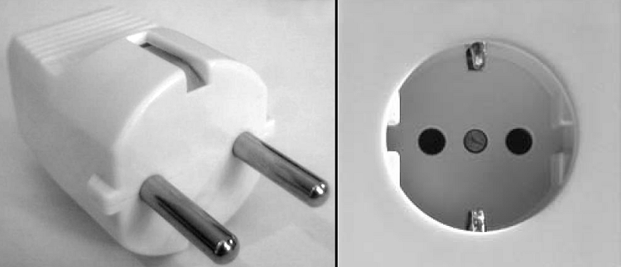 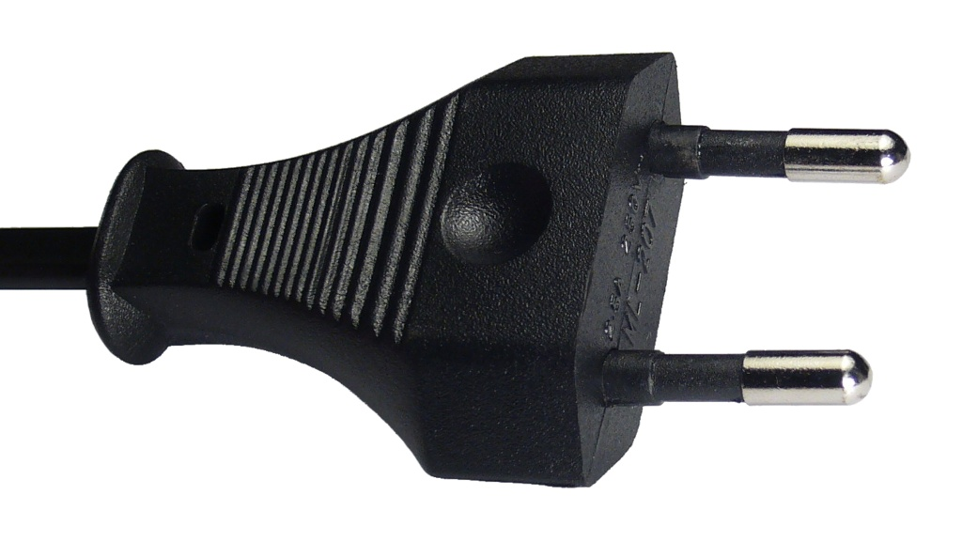 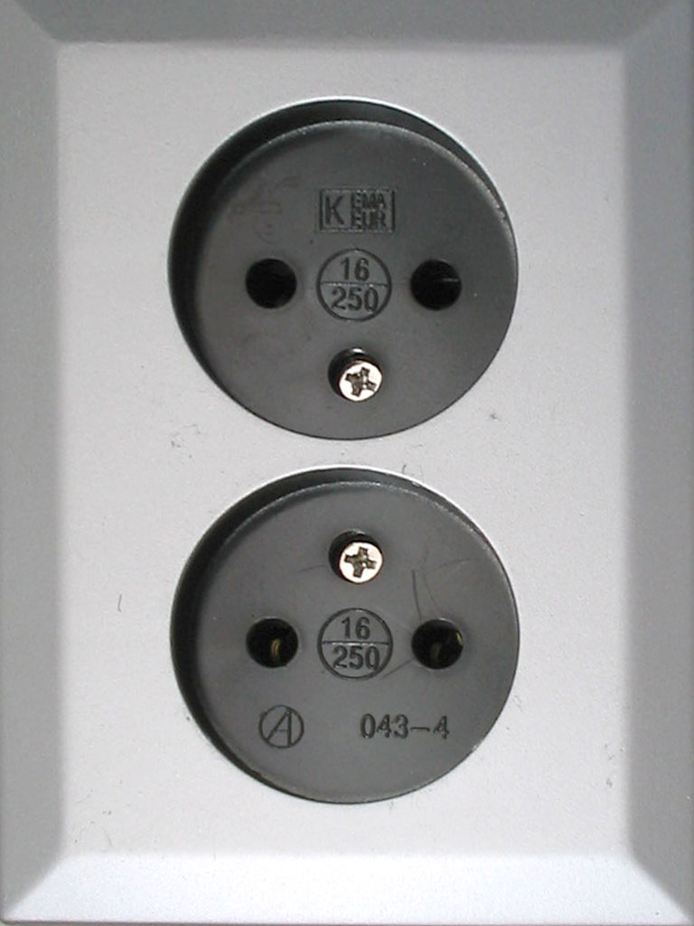

Useful numbers

• Dial code for Latvia: +371

• Emergency: call 112, the EU-wide emergency number for the police, fire and ambulance services

Useful information about Latvia

Useful information about Latvia can be found at [www.tava.gov.lv/en](http://www.tava.gov.lv/en) and [www.latvia.eu](http://www.latvia.eu/).

Use an application to learn more about Latvia while using your phone: the *Latvia.Travel.* This application is available on Google Play Store and iTunes and the also have a website at <http://latvia.travel/>

**Contact Persons**

|  |  |
| --- | --- |
| **Elīna Neimane**  Latvian Ministry of Defence  Mobile Phone:  E-mail: [Elina.Neimane@mod.gov.lv](mailto:Elina.Neimane@mod.gov.lv) | **Ms Dimitra Liveri**  Security and Resilience of Communication Networks Officer  European Union Agency for Network and Information Security (ENISA)  1 Vass Sofias & Meg. Alexandrou, Marousi, GR-GR-151 24, Greece  Mobile Phone: +30 6948725557  E-mail: [Dimitra.Liveri@enisa.europa.eu](mailto:Dimitra.Liveri@enisa.europa.eu) |